**Other students permisson agreement**

15/10/2025

The students involved in the first evaluation call version of the Acme-ANS project of the group C3.056 are:

* Pablo Jose Bermúdez Imaz
* Rubén López Expósito
* Ángel Sánchez Ruiz
* Javier Clavijo Martinez
* Alejandro Vargas Muñiz

The students involved in the second evaluation call (C3) version of the Acme-ANS project of the group C3.056 are:

* Pablo Jose Bermúdez Imaz

I kindly ask permisson to Javier Clavijo Martinez Alejandro Vargas Muñiz, Rubén López Expósito and Ángel Sánchez Ruiz in order to use the materials (documents, code, etc) provided and created by them in the past versions of the project.

Javier Clavijo Martinez

“I, Javier Clavijo Martínez, give my permission for the use of all material provided and created by me in all previous versions of the project.”

Signature:

Alejandro Vargas Muñiz

“I, Alejandro Vargas Muñiz, give my permission for the use of all material provided and created by me in all previous versions of the project.”

Signature:

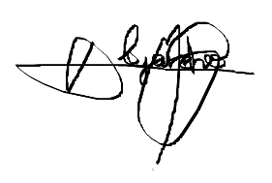

Rubén López Expósito

“I, Rubén López Expósito, give my permission for the use of all material provided and created by me in all previous versions of the project.”

Signature:



Ángel Sanchez Ruiz

“I, Ángel Sánchez Ruiz, give my permission for the use of all material provided and created by me in all previous versions of the project.”

Signature:

